Marketing automation architecture

Problem statement / pain points.
  - Homepage / Products page Personalization. (feature stores).
    - Static offers -> we need to personalize it per customer
  - Next-best action.
    - Abandon card
    - Potential Churned customers
  - New users (cold start).
  - Agentic Marketing - Campaign Automation.
    - Generate new marketing campaigns by agentic ai

Goals / non-goals, Solution Assumptions.
- Goals
Design a personalization and agentic marketing system
That should increase the CSAT to 80% after current 60%
By measuring customer rating and text feedback
- Non-Goals
Lower refund

As-Is Architecture, Explore the Enterprise Architecture.
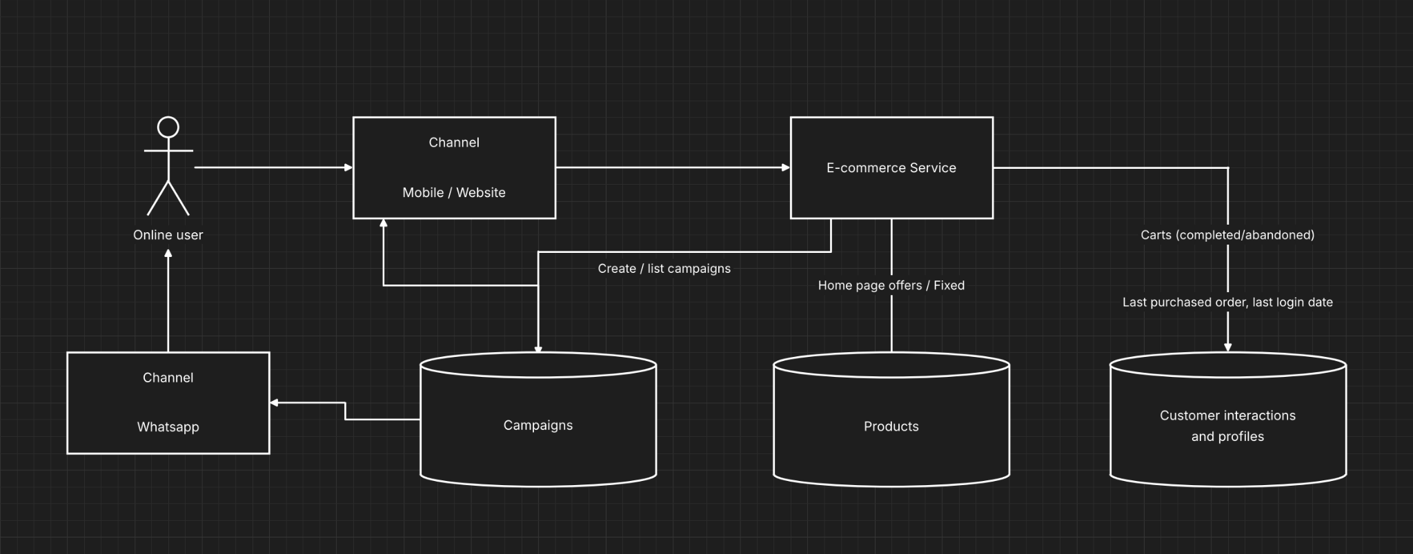

Assumptions:
- Number of concurrent users based on last 6 months(50 users)
seasonality(Ramadan , holidays) peak hours , 100 users

Architecture principles, key decisions and trade-offs.
security/ compliance
  - Data should be stored in country
  - GDPR
  - PDPL/PII “data privacy”
  - Guardrail to achieve the clean text an AI limit errors , prompt injection
All internal system should be behind vpn
All external system should be authenticated and use https

Context view
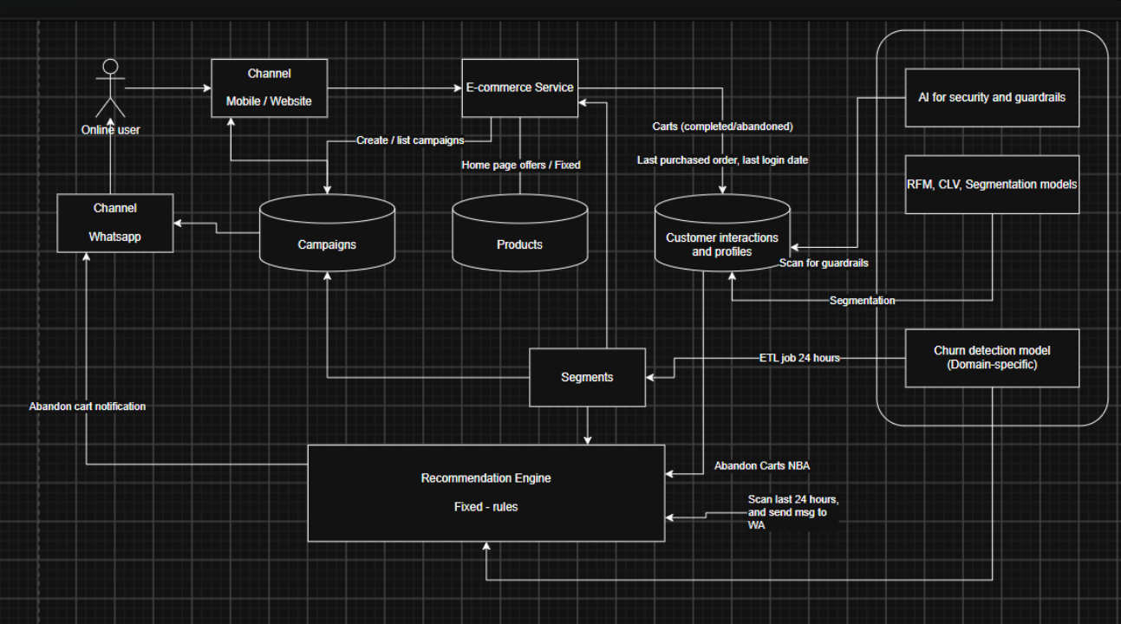

Deployment
2 nodes active -active , 4 cores cpu , 16 giga RAM , 2 podes for every node

Data view point
Retention policy : all customers data should be kept at least 5 years

Assessment.

Priorities.

